**The Montgomery County Historical Society  
& History Museum**

36 Broadway Street, Mt. Sterling, KY 40353

Phone: 859-498-4669 Website: mchmky.com Email: mchmky@gmail.com

Twitter: @mchmky Instagram: mchmky.com

***Newsletter for May 2023***

"**Mission: t*o procure, preserve, exhibit and disseminate the history of our community".***

Happy May!! Well, it seems this year’s meetings are off to a roaring start. I am happy to say 59 people were in attendance to April’s meeting. I would like to thank Dr. Mel Hankla for his presentation about his book, Into The Bluegrass, and his generosity for displaying the Kentucky Longrifles and other antiques related to colonial Montgomery County and other parts of our great state of Kentucky. Now, let’s talk about May and the upcoming months.

The Montgomery County Historical Society will hold May meeting on Monday, May 22nd. Dinner will start at 6:00 at the Episcopal Church with the meeting to follow at 7:00. A potluck as always, so bring a dish or a dessert. The little Hen will be there to accept your contribution for the chicken. I will continue to be accepting dues - $20 for individual and/or family – and donations.

Mayor Al Botts will be our guest speaker. The topic will be “*A Decade of Growth and Change – Mt. Sterling 1900 – 1910*”.

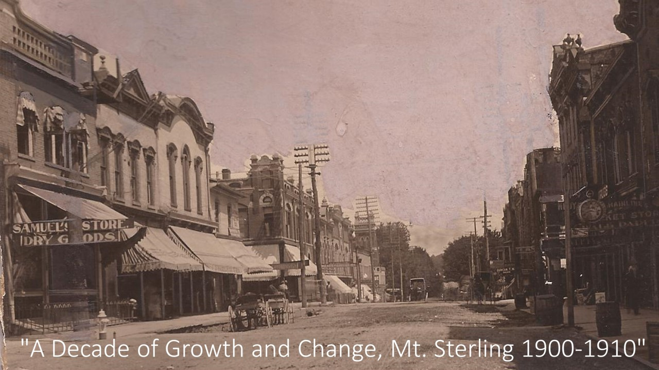

Here are the minutes for our April meeting:

I.                     Pre-meeting pot luck @ 6:10 pm.

II.                   The Meeting was called to order by President, Keven Tutor @ 7:00 pm.

III.                 Our guest speaker for the evening, Mel Hankla was introduced. Mr. Hankla is the author of the book,  “Into The Bluegrass.” He shared factual stories about items that are pictured in his book.

IV.                 Next meeting- May 22nd . Guest speaker will be Al Botts, who will discuss early 20th century Mt Sterling.

The following is a list of our upcoming speakers &/or topics for the year. This list is subject to change at any time. If anyone has an idea, speaker or topic this wish to hear about in 2024, please contact me or Kevin Tudor.

June- Eddie Price- War of 1812

July-Charles Bishop- His book "Morgan’s Station: The Last Indian Raid in Kentucky".

Aug-Barry Tonning- Sheltowee Trace

Sept-Ken Darnell- Civil War in Montgomery County

Oct-Rob Kiskaden (topic is unknown at this time).

Nov- Business Meeting

You can continue to keep track of us on Facebook, Instagram and Twitter.

Thank you and enjoy the month of May.

Sincerely,

Jo Ann Oborski